Project Design Phase-II
Technology Stack (Architecture & Stack)
Date
Team ID | SWTID-2026-6651
Project Name | AI WeatherWise API
Maximum Marks | 4 Marks
Technical Architecture:
The AI WeatherWise application is a RESTful backend platform built with Node.js and Express.js. It uses MongoDB with Mongoose ODM for data persistence, OpenWeatherMap for real-time weather data, and Google Gemini AI for weather summaries and personalized recommendations. The backend follows MVC architecture and separates routing, controllers, middleware, models, and utility modules.
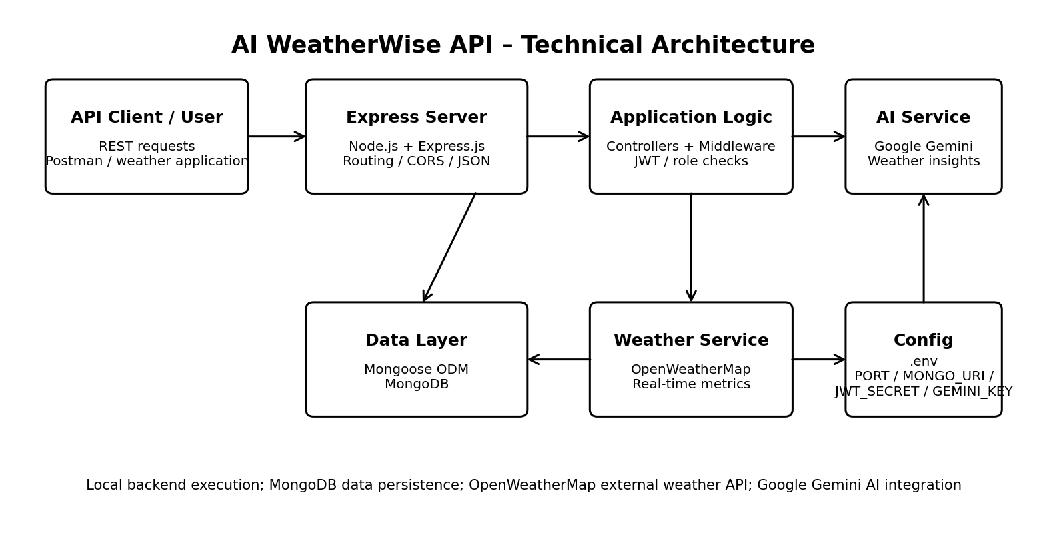
Architecture coverage: Application logic, infrastructure, external interfaces, data storage, and AI service integration are shown above. The source documentation describes local Node.js execution; it does not specify a cloud deployment.
Table-1 : Components & Technologies
S.No | Component | Description | Technology
1 | User Interface | Headless backend interface through REST API routes; API clients can send requests and receive JSON. Postman is used for API testing. | Express.js REST API; Postman
2 | Application Logic-1 | Server logic, HTTP routing, JSON payload parsing, CORS handling and API gateway functions. | Node.js + Express.js
3 | Application Logic-2 | Authentication and authorization middleware validates JWT tokens and role permissions for protected routes. | JWT authentication; bcrypt password hashing
4 | Application Logic-3 | Generates weather summaries and personalized recommendations from live temperature and weather conditions. | @google/generative-ai / Google Gemini AI
5 | Database | Document-oriented data persistence using Mongoose schemas and MongoDB. The documentation describes User and Location entities. | MongoDB + Mongoose ODM
6 | Cloud Database | Cloud database service is not specified in the documentation. | Not specified
7 | File Storage | Dedicated file-storage service is not specified in the documentation. | Not specified
8 | External API-1 | Provides real-time weather metrics used by the backend. | OpenWeatherMap
9 | External API-2 | AI service used to generate weather summaries and personalized recommendations. | Google Gemini AI / Gemini API
10 | Machine Learning Model | AI integration used for natural-language weather insights and personalized recommendations. | Google Gemini AI
11 | Infrastructure (Server / Cloud) | Backend is executed locally using Node.js. The documentation specifies Windows 10/11, macOS or Linux and local server execution. | Node.js; Local execution; Windows/macOS/Linux
Table-2: Application Characteristics
S.No | Characteristics | Description | Technology
1 | Open-Source Frameworks | The backend uses an MVC-based modular architecture with Node.js and Express.js. Mongoose is used for MongoDB data access. | Node.js, Express.js, Mongoose
2 | Security Implementations | Secure JWT authentication, bcrypt password hashing, role-based route guarding, request/payload sanitization, centralized error handling, and safeguards against XSS and NoSQL parameter manipulation. | JWT, bcrypt, role-based middleware, request sanitization
3 | Scalable Architecture | The application separates routing, controllers, middleware, models, and utility modules. MVC is used to decouple business logic from data management and improve maintainability and scalability. | MVC architecture; Node.js; Express.js; Mongoose
4 | Availability | The platform includes a resilient fallback mode that maintains API functionality even without external API keys. The documentation does not specify load balancers or distributed servers. | Fallback mode; centralized error handling
5 | Performance | Mongoose translates application logic into native MongoDB queries. The architecture uses modular processing and the documentation does not specify request-per-second targets, caching, or CDN usage. | Mongoose + MongoDB; modular backend architecture
Source note: The converted content is based on the supplied AI WeatherWise documentation. Cloud database, dedicated file storage, load balancers, distributed servers, cache/CDN, and request-per-second targets are not specified in that documentation and have therefore not been invented.
Team details from source: Team Leader: Deepika.N; Team Members: Siva.M, Veerasekar.S, Shyamkumar.A. The Team ID itself is not provided.

